**Cookbook Documentation**

**1. Introduction**

* **Project Title:** Cookbook - A Virtual Kitchen Assistant
* **Team Members:**
  + **Team Leader:** B. Bharath Kumar - [smartbharath046@gmail.com](mailto:smartbharath046@gmail.com)
  + **Team Member:** A. Vignesh - [vickyanandan9710@gmail.com](mailto:vickyanandan9710@gmail.com)
  + **Team Member:** P. Guruprasath - [Gprasath771@gmail.com](mailto:Gprasath771@gmail.com)
  + **Team Member:** A. Joseph Antony - [josephicsanthony@gmail.com](mailto:josephicsanthony@gmail.com)
* **Team ID:** SWTID1741326638146407

**2. Project Overview**

* **Purpose:** Cookbook is an advanced React.js application designed to help users explore, manage, and create recipes effortlessly. It provides a user-friendly platform for both novice and professional chefs.
* **Features:**
  + Recipe browsing with lazy loading
  + Search functionality and category navigation
  + Detailed recipe views with YouTube video integration
  + Trending dishes and responsive design
  + Favorite recipes feature for easy access

**3. Architecture**

* **Component Structure:**
  + **Navbar**: Provides navigation and search functionality
  + **Hero**: Displays a welcoming section with a call to action
  + **RecipeList and RecipeCard**: Render lists of recipes with lazy loading
  + **Category**: Filters recipes by cuisine
  + **SearchResults**: Displays results based on user queries
  + **RecipeDetails**: Shows recipe information and embedded videos
  + **Favorites**: Displays saved recipes with remove functionality
  + **Footer**: Provides a simple footer with copyright details
* **State Management:** Uses React's built-in state and Context API
* **Routing:** Uses react-router-dom for seamless navigation

**4. Setup Instructions**

* **Prerequisites:**
  + Node.js (Download from <https://nodejs.org/en/download/>)
  + React.js installed using npx create-react-app cookbook-dashboard
  + Git (Version control system)
  + Development Environment (e.g., VS Code, WebStorm)
  + YouTube API Key for video integration
* **Installation:**
  + Clone the repository: **git clone https://github.com/Bharathkumarz01/Cookbook--a-virtual-kitchen-assistant.git**
  + Install dependencies: **npm install**
  + Start the application: npm start
  + Open in browser: **http://localhost:3000**

**5. Folder Structure**

Cookbook/

├── public/

│ ├── index.html

│ ├── favicon.ico

│ ├── logo192.png

│ ├── manifest.json

│ └── robots.txt

└── src/

├── components/

│ ├── Hero.jsx

│ ├── RecipeList.jsx

│ ├── RecipeCard.jsx

│ ├── Navbar.jsx

│ └── Footer.jsx

├── features/

│ ├── RecipeDetails.jsx

│ ├── SearchResults.jsx

│ ├── Home.jsx

│ ├── Category.jsx

│ ├── Favorites.jsx

├── hooks/

│ └── useRecipes.js

├── styles/

│ ├── App.css

│ └── index.css

├── App.js

├── index.js

└── reportWebVitals.js

**6. Running the Application**

* **Frontend:** Start the server with:
* npm start
  + Runs the project on http://localhost:3000

**7. Component Documentation**

* **Key Components:**
  + Navbar.jsx: Manages site navigation
  + RecipeList.jsx: Displays a list of recipes
  + RecipeCard.jsx: Shows individual recipe details
  + RecipeDetails.jsx: Displays in-depth information with video
  + Favorites.jsx: Manages saved recipes
* **Reusable Components:**
  + Button.jsx: Custom buttons
  + Card.jsx: Reusable card structure for displaying recipes

**8. State Management**

* **Global State:** Context API manages favorite recipes and search state.
* **Local State:** React useState for handling UI updates.

**9. User Interface**

* **Screenshots:** Included in the GitHub repository.
* **UI Features:**
  + Responsive design for mobile and desktop
  + Recipe browsing with high-quality images
  + Interactive search functionality

**10. Styling**

* **CSS Frameworks/Libraries:**
  + Custom CSS with App.css and index.css
  + Tailwind CSS for responsive design
* **Theming:** Uses a warm, earthy "Village Cooking Theme."

**11. Testing**

* **Testing Strategy:**
  + Unit tests with Jest and React Testing Library
  + Manual testing of UI interactions
* **Code Coverage:** Ensures proper coverage for major components.

**12. Screenshots or Demo**

* **LiveDemo:**https://drive.google.com/drive/folders/1Zf3Rb6bV_BaIWBEIxcmI4uQ9usRtTSqX?usp=drive_link
* **GitHub Repository:** <https://github.com/Bharathkumarz01/Cookbook--a-virtual-kitchen-assistant.git>

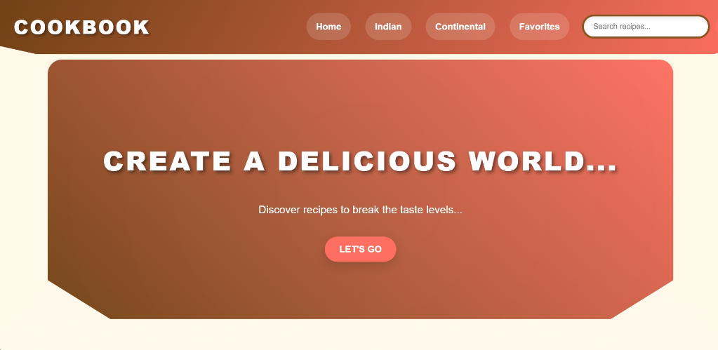

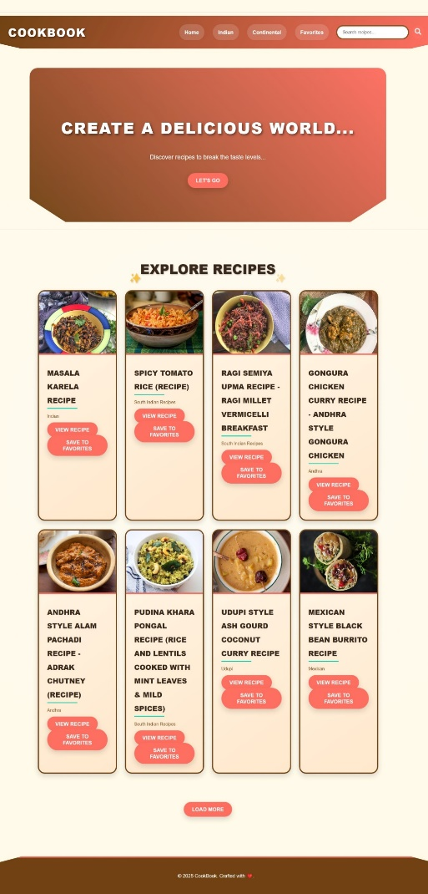

* **Search Results Page**: Shows filtered recipes with a centered title.

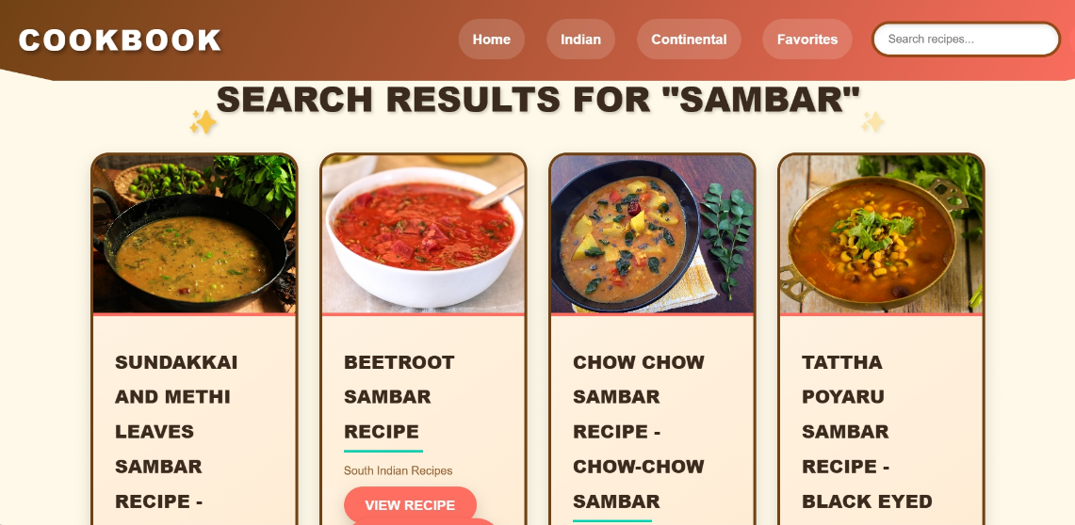

* **Recipe Detail Page:** Includes a full-width image, split layout for ingredients and instructions, and a YouTube video embed.

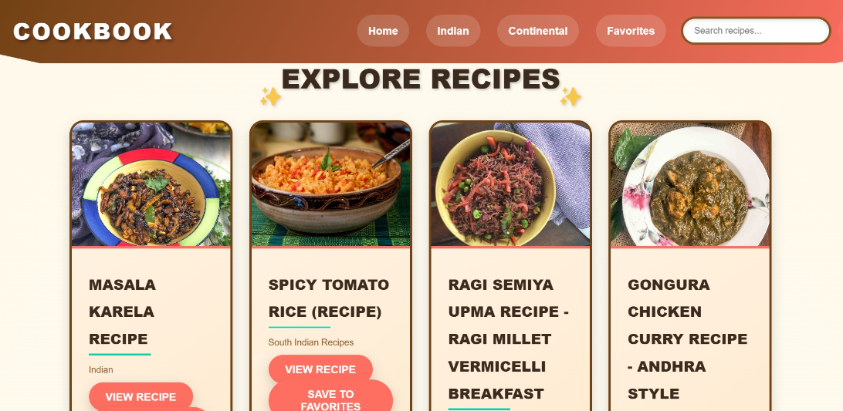

* **Favorites Page**: Displays a grid of saved recipes with "Remove" buttons.

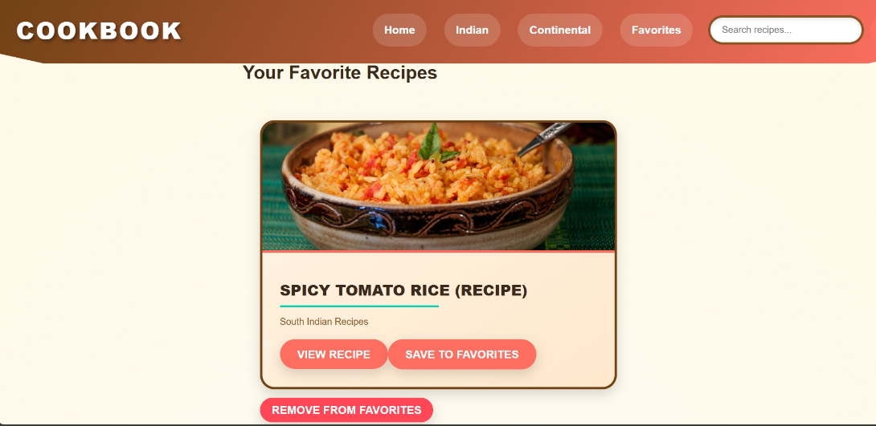

**13. Known Issues**

* API rate limits can cause intermittent loading issues
* Some recipes may lack video integration due to missing YouTube links

**14. Future Enhancements**

* **New Features:**
  + User authentication and profile management
  + Meal planner and grocery list integration
  + Improved search with filters for dietary preferences
  + Dark mode for better accessibility